
EE108 Optoelectronics Intellisense

Study Report

on

Photonics for Healthcare: AI Denoising in Medical Imaging

Submitted by: 何衍宁
Email: 12311512@mail.sustech.edu.cn

18 May 2025

Table of Contents
Table of Contents 1
Chapter 1 Introduction 2
Chapter 2 Results and Discussion 3-4
Chapter 3 Conclusions 5-6
References 7
Appendix 8-11

Introduction

In the realm of medical imaging, noise reduction is a critical issue that impacts both diagnostic precision and patient outcomes. Noise in medical images can obscure vital details, leading to potential misinterpretations and increased radiation exposure. This challenge has spurred the development of advanced denoising techniques, with artificial intelligence (AI) emerging as a transformative solution. AI-driven methods offer the potential to significantly enhance image quality while minimizing radiation doses and improving diagnostic accuracy.
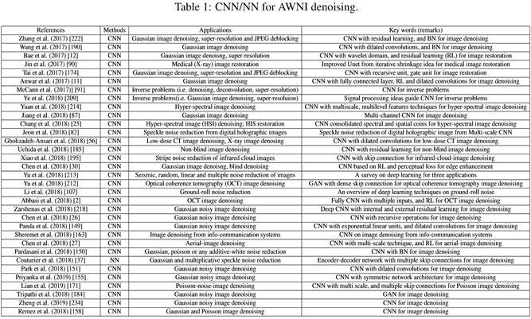
Recent advancements in AI, particularly deep learning algorithms such as convolutional neural networks (CNNs) and generative adversarial networks (GANs), have shown remarkable promise in addressing the noise problem. These techniques leverage complex neural architectures to learn and remove noise patterns from images, resulting in clearer and more accurate diagnostic outputs. The application of AI in medical photonics has expanded across various imaging modalities, including CT, MRI, and PET scans, demonstrating its versatility and effectiveness.
This report aims to explore the latest developments in AI-based denoising technologies within medical photonics. By integrating AI with medical imaging, we are on the cusp of a new era where high-quality, low-dose imaging becomes the norm, ultimately benefiting both healthcare providers and patients.

Results and Discussion

2.1 Applications of AI Denoising in Medical Imaging
AI-based denoising techniques have significantly transformed the landscape of medical imaging by enhancing the quality of diagnostic images. Traditional denoising methods, such as Gaussian filtering and wavelet transforms, often fail to effectively remove complex noise patterns while preserving critical diagnostic details (Walid El-Shafai et al., 2024). These methods, although widely used, tend to blur important image features, leading to potential misinterpretations and reduced diagnostic accuracy. In contrast, AI-driven approaches, particularly those leveraging deep learning algorithms like convolutional neural networks (CNNs) and generative adversarial networks (GANs), have demonstrated superior performance in noise reduction while maintaining image fidelity.
For instance, Naqvi et al. (2024) developed a GAN-aided low-noise discriminator that effectively distinguishes between linear and sparse pixel distributions, resulting in high-precision image reconstruction. This method leverages the adversarial training process to learn the noise patterns and generate cleaner images. Similarly, Transformer-based deep networks have shown remarkable capabilities in denoising tasks, leveraging their ability to model long-range dependencies in image data (Alanazi et al., 2024). These networks are particularly effective in handling high-frequency noise and preserving fine details, which are crucial for accurate diagnosis.
Figure 1: Graphical representation of the proposed GAN-LND method.
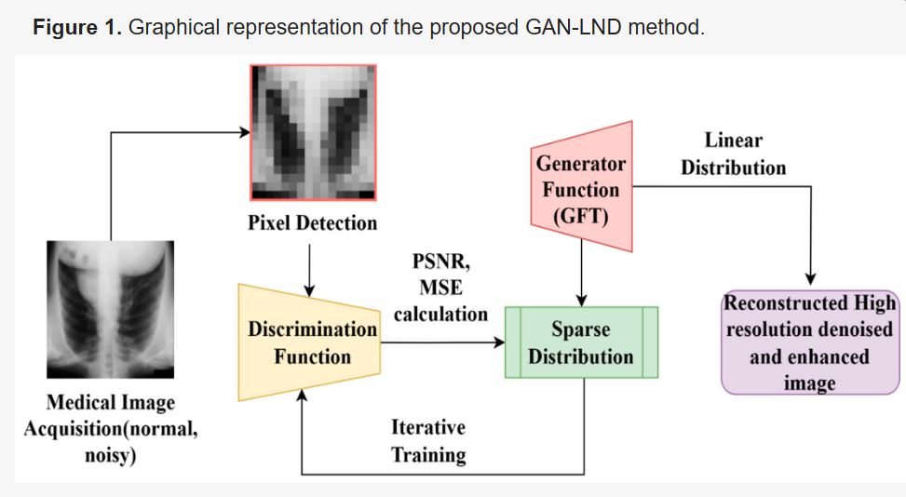
2.2 Comparison of Different AI Denoising Methods
The comparison between traditional and AI-based denoising methods highlights the significant advantages of AI techniques. Traditional methods, such as Gaussian filtering and wavelet transforms, are limited in their ability to handle complex noise patterns and often blur important image features (Walid El-Shafai et al., 2024). These limitations are particularly evident in high-noise environments, where traditional methods struggle to differentiate between noise and actual image content. In contrast, AI-based methods, including CNNs and autoencoders, have demonstrated superior performance in adapting to various noise types and preserving diagnostic details.
For example, a diffusion-based denoising model has shown significant improvements in PET image quality by effectively reducing noise while maintaining critical anatomical structures (Gong et al., 2023). This model leverages the principles of diffusion processes to iteratively refine the image, resulting in a cleaner output without losing important details. Similarly, multi-task learning combined with GANs has proven effective in low-dose CT denoising, enhancing image quality without compromising diagnostic accuracy (M. Kalaiyarasi et al., 2023). This approach utilizes the adversarial training process to learn the noise patterns and generate cleaner images, while the multi-task learning framework ensures that the denoised images retain their diagnostic value.
2.3 Future Directions of AI Denoising
The future of AI denoising in medical imaging holds great promise, with several exciting directions on the horizon. One key area is cross-modal denoising, where AI techniques are applied to multiple imaging modalities simultaneously, such as MRI-CT registration. This approach can enhance the diagnostic value by integrating complementary information from different modalities (Møller et al., 1983). For example, combining MRI and CT images can provide a more comprehensive view of the patient's anatomy, leading to more accurate diagnoses. Cross-modal denoising can also help in reducing the radiation dose by optimizing the use of lower-dose imaging modalities while maintaining diagnostic accuracy.
Another promising direction is real-time denoising, which involves developing AI algorithms capable of processing and denoising images in real-time during the imaging process. This can significantly reduce the time required for diagnosis and improve patient throughput. Real-time denoising is particularly important in dynamic imaging scenarios, such as functional MRI or PET scans, where rapid processing is essential for accurate diagnosis and treatment planning.
Lastly, personalized denoising models tailored to individual patient characteristics are expected to become more prevalent, offering customized solutions that optimize diagnostic outcomes for each patient. These models can take into account factors such as patient age, medical history, and specific imaging requirements, providing more accurate and reliable diagnostic results. Personalized denoising can also help in reducing the overall radiation dose by optimizing the imaging parameters for each patient, leading to safer and more effective diagnostic procedures.

Conclusions

3.1 Summary of Findings
The integration of AI-driven denoising techniques into medical imaging represents a significant leap forward in enhancing diagnostic capabilities and improving patient outcomes. Traditional denoising methods, while effective in certain contexts, often fall short in addressing the complex noise patterns present in modern medical images. In contrast, AI-based approaches, particularly those leveraging deep learning algorithms such as CNNs, GANs, and Transformer networks, have demonstrated remarkable efficacy in noise reduction while preserving critical diagnostic details. These advanced techniques not only improve image quality but also contribute to reduced radiation exposure and faster diagnostic processes.
The applications of AI denoising span across various imaging modalities, including CT, MRI, and PET scans, showcasing the versatility and adaptability of these methods. The ability to handle different types of noise and maintain image fidelity has positioned AI as a transformative tool in medical imaging. Moreover, the ongoing advancements in AI technology continue to push the boundaries of what is possible, paving the way for even more sophisticated and effective denoising solutions.
Figure 2: The PSNR (left column) and SSIM (right column) values using different methods calculated based on 20 [18F]MK-6240 test datasets for 1/4 low-dose (top row) and 1/16 low-dose datasets. ***, **, *, ns, located at the top of the bar plot represents p-value< 0.001, p-value< 0.01, p-value< 0.05, and p-value≥ 0.05, respectively.

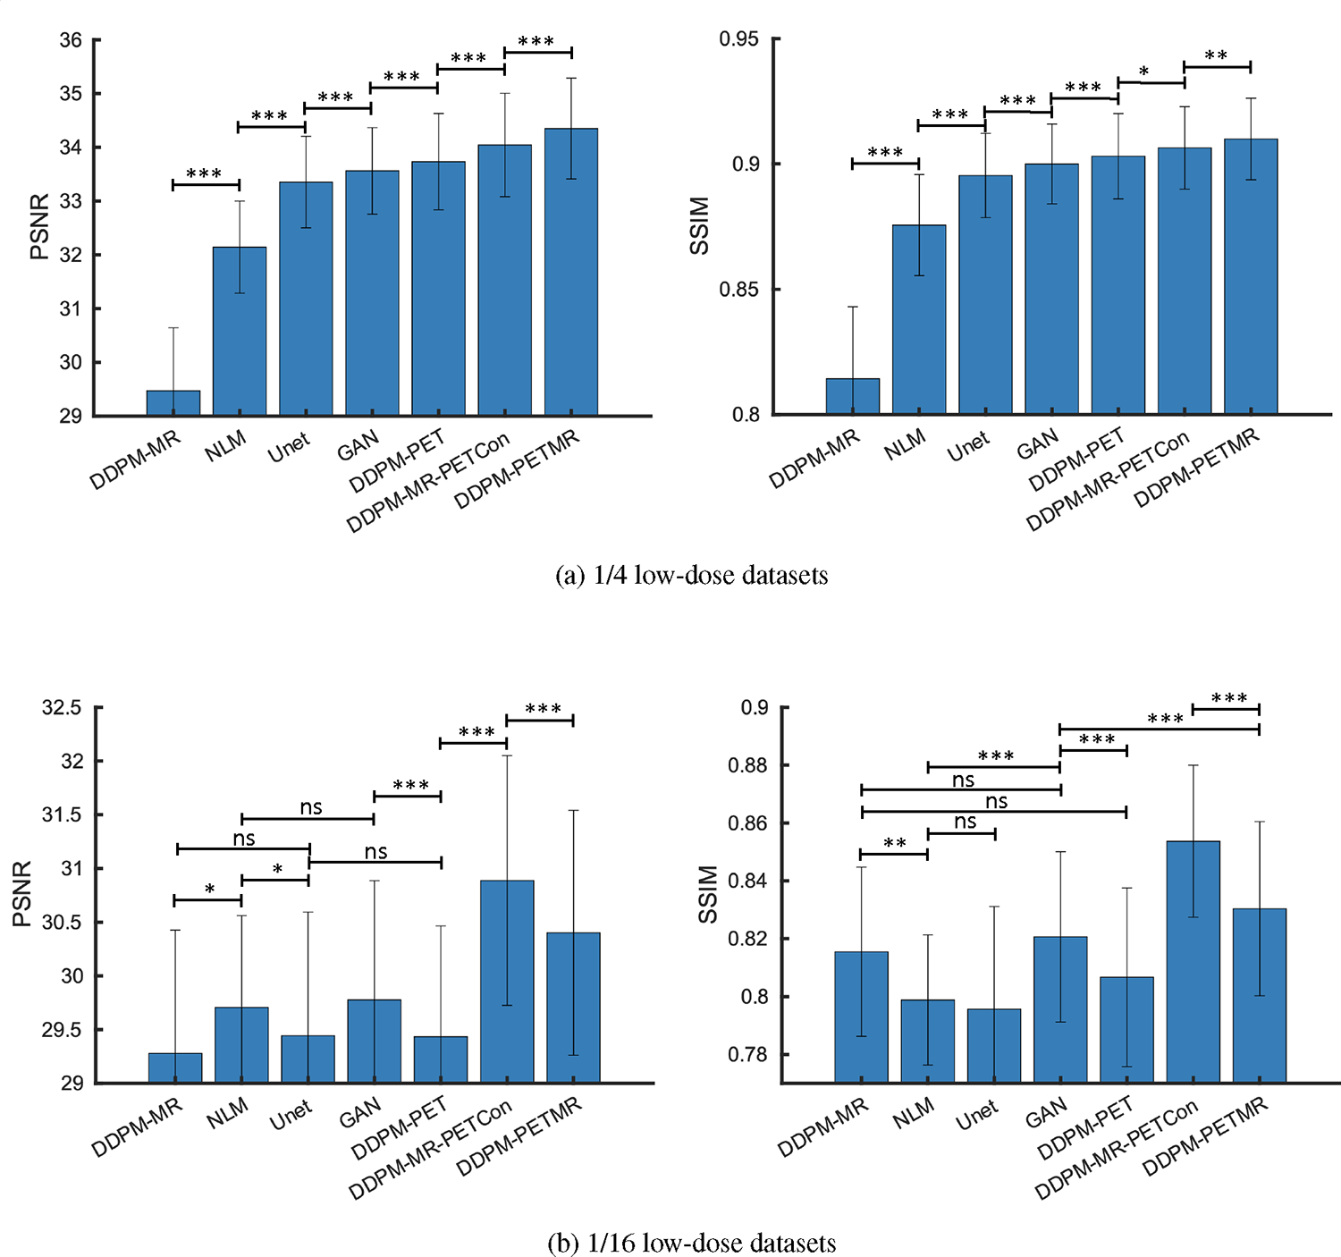
3.2 Future Implications
Looking ahead, the future of AI denoising in medical imaging is both promising and exciting. The development of cross-modal denoising techniques, real-time denoising algorithms, and personalized denoising models holds the potential to further revolutionize the field. Cross-modal denoising, which integrates information from multiple imaging modalities, can provide a more comprehensive and accurate diagnostic picture. Real-time denoising algorithms have the potential to significantly reduce the time required for image processing, thereby enhancing the efficiency of diagnostic workflows. Personalized denoising models, tailored to individual patient characteristics, can optimize diagnostic outcomes and contribute to more precise and patient-centered care.
The widespread adoption of AI denoising techniques in clinical settings could lead to substantial improvements in diagnostic accuracy and patient safety. By reducing noise and enhancing image clarity, these techniques can help clinicians make more informed decisions, ultimately leading to better patient outcomes. Additionally, the ability to achieve high-quality imaging with lower radiation doses aligns with the broader goal of minimizing patient exposure to ionizing radiation, thereby reducing potential health risks.
3.3 Conclusion
In conclusion, AI-driven denoising techniques are poised to play a crucial role in the future of medical imaging. The ability to effectively remove noise while preserving diagnostic details is a significant step forward in enhancing the quality and reliability of medical images. As AI technology continues to evolve, we can expect even more advanced and sophisticated denoising solutions that will further improve diagnostic capabilities and patient care. The integration of AI into medical imaging is not just a technological advancement but a critical step towards more accurate, efficient, and personalized healthcare.

References
[1] Walid El-Shafai, Samy Abd El-Nabi, Ali, A. M., El-Rabaie, E.-S. M., & Fathi. (2023). Traditional and deep-learning-based denoising methods for medical images. Multimedia Tools and Applications, 83(17), 52061–52088. https://doi.org/10.1007/s11042-023-14328-x‌
[2] Alanazi, T. M., & Mercorelli, P. (2024). Precision Denoising in Medical Imaging via Generative Adversarial Network-Aided Low-Noise Discriminator Technique. Mathematics, 12(23), 3705. https://doi.org/10.3390/math12233705‌
[3] Gong, K., Johnson, K., Georges El Fakhri, Li, Q., & Pan, T. (2023). PET image denoising based on denoising diffusion probabilistic model. European Journal of Nuclear Medicine and Molecular Imaging. https://doi.org/10.1007/s00259-023-06417-8
[4] Naqvi, R. A., Haider, A., Kim, H. S., Jeong, D., & Lee, S.-W. (2024). Transformative Noise Reduction: Leveraging a Transformer-Based Deep Network for Medical Image Denoising. Mathematics, 12(15), 2313–2313. https://doi.org/10.3390/math12152313
[5] M. Kalaiyarasi, R. Janaki, Sampath, A., Dharmendra Ganage, Yugendra Devidas Chincholkar, & Srinivas Budaraju. (2023). Non-additive noise reduction in medical images using bilateral filtering and modular neural networks. Soft Computing. https://doi.org/10.1007/s00500-023-08968-2‌
[6] Møller, M., & Korf, H. W. (1983). Central innervation of the pineal organ of the Mongolian gerbil. A histochemical and lesion study. Cell and Tissue Research, 230(2), 259–272. https://doi.org/10.1007/BF00213804
‌

Appendix: CNN/NN for AWNI denoising


Designing network structures based on the properties of noise is of critical importance. The following methods can be employed for network structure design: (1) Utilizing multiple perspectives to design the network; (2) Modifying the loss function; (3) Increasing the width or depth of the Convolutional Neural Network (CNN); (4) Incorporating arbitrary plug-ins within the CNN; (5) Employing skip connections or cascaded operations within the CNN.
Supplementary explanations: For method (1), there are three types: using a noisy image as the input to multiple sub-networks; employing different perspectives of a single sample as the input to the network; and utilizing different channels of a network as the input. For method (4), arbitrary plug-ins include activation functions, dilated convolutions, fully connected layers, and pooling layers, among others. For method (5), it includes both skip connections and cascaded operations. Table 1 provides a summary of CNNs/NNs for AWNI denoising.

Appendix: Graphical Representation of the Proposed GAN-LND Method
The proposed Generative Adversarial Network (GAN)-aided Low-Noise Discriminator (LND) method is designed to process the images acquired from the medical field. PSNR is extensively used in image processing research since it measures picture quality by assessing the similarity between the original and denoised images. It offers an impartial assessment of the efficacy of noise reduction while maintaining the image’s structural and textural integrity. In medical imaging, PSNR is a dependable metric for evaluating noise reduction efficacy, with higher PSNR values indicating superior retention of diagnostically significant features. The noise in the acquired image becomes difficult to reduce; at that time, the low-level segment features are disparate when tuning the PSNR, regardless of the pixel arrangement and distribution. The generator discriminator-balanced linear function is used for analyzing normal and noisy images based on the segmented features. The PSNR is computed using pixel arrangement and pixel distribution to identify the peak error. Peak error denotes the highest absolute difference between matching pixels in the original and reconstructed (denoised) pictures. This statistic is essential for assessing the worst-case scenario in picture quality deterioration, especially pertinent in medical imaging, where slight errors might influence diagnostic decisions. This ratio is aided as a quality measurement between normal and noise images, where maximum fluctuation in the input images is identified. The PSNR is measured to control noisy pixels in the input images, which are pursued using the proposed method. The mean squared error (MSE) value measures PSNR to compare image quality. The normal input image is represented as (IMG1(r,c))(IMG1r,c), and the compressed (reconstructed) image is represented as (IMG2(r,c))(IMG2r,c), processed and compared using PSNR measurement, and low-level segment features are disparate. Hence, based on pixel detection, the proposed method mainly performs two processes, including linear distribution.
Medical imaging noises, such as speckle, salt and pepper, and Gaussian, are handled well by the suggested Generative Adversarial Network (GAN)-aided Low-Noise Discriminator (LND). While the generator creates denoised images from scratch, the discriminator improves noise suppression by zeroing in on residual noise’s spatial and statistical properties due to the Low-Noise Discriminator module. By capitalizing on the predictable statistical distributions and textural patterns of both speckle and Gaussian noise, the strategy outperforms previous approaches in minimizing both types of noise. On the other hand, the sparsity and irregularity of highly impulsive noises like salt and pepper make them difficult to handle. To ensure the model generalizes successfully across varied noise profiles, it is important to include adaptive training mechanisms, such as loss functions that are particular to the noise or focused augmentation procedures, to increase performance for specific types of noise.
From the diagrammatic illustration in Figure 1 below, the proposed LND method involves the following steps.


Appendix: Low-Dose Datasets
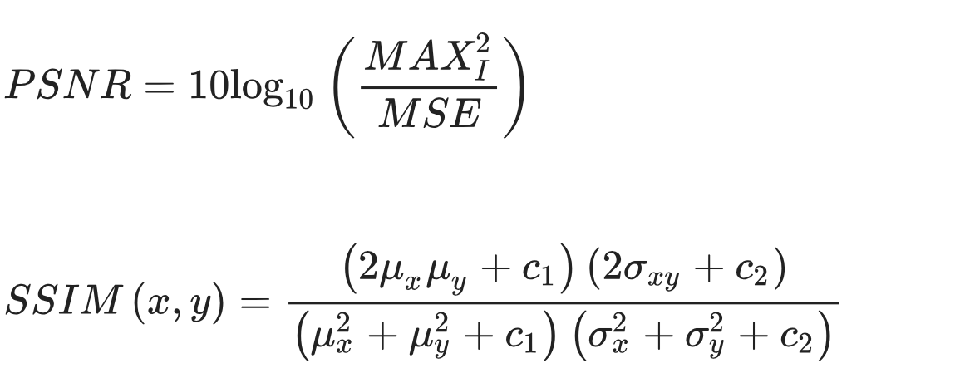
Figure showed the PSNR and SSIM values of different methods based on 20 test datasets. These global quantification values showed that DDPM-PETMR had the best performance and was more robust to the noise levels during testing, followed by DDPM-MR-PETCon.

